TEAM TECHNICAL ARTEFACT 7

Risk Assessment & Security Controls Report

Explainable and False-Positive-Aware Hybrid Unsupervised Network Anomaly Detection for Australian SME Financial Services
COIT20265 Networks and Information Security Project | Group PG3 | HT2 2026
Team Members: Labannya Barua | Syed Rubaiyat Karim | Arjita Saha | Mst Sinha Naznin
CQUniversity Australia | October 2026

Executive Summary
This technical artefact presents the project-specific risk assessment and security-control design for the unsupervised network anomaly-detection prototype. It focuses on risks that arise from the data pipeline, model and threshold behaviour, the GNS3/VMware/Zeek laboratory, alert storage, the Streamlit analyst interface, software dependencies and the evidence/repository workflow. Detailed legal, privacy and professional analysis is intentionally separated into Technical Artefact 10; this document addresses privacy only where it creates a concrete security risk or control requirement.
The assessment uses a 5 x 5 likelihood-impact model informed by the structure of NIST SP 800-30 Rev. 1 and organised around the risk-management outcomes of NIST Cybersecurity Framework (CSF) 2.0. Australian implementation guidance is also considered through the Australian Signals Directorate (ASD) Information Security Manual and Essential Eight. These frameworks are used as design references, not as a claim that the student prototype is formally compliant or certified.
The highest inherent risks are cross-domain score shift, false-positive overload, missed attacks, threshold drift, unrepresentative calibration data and model/data contract failure. Project testing provides direct evidence for several of these risks: frozen source thresholds produced extremely high target-domain false-positive rates, practical normal traffic varied between capture sessions, and the current Hybrid score showed saturation that limited threshold control. The risk response therefore treats model quality, threshold provenance and representative target-normal calibration as security controls rather than as purely statistical tuning decisions.
The current prototype already implements several meaningful controls: attack generation is isolated in the GNS3/VMware lab; Zeek is used passively; saved preprocessing and fixed feature ordering reduce model/data mismatch; calibration records are separated from held-out evaluation; FPR is measured explicitly; PCAP/log evidence is retained; and the dashboard remains analyst-facing with no automatic blocking. Before any real financial-services deployment, the report recommends stronger authentication and role-based access, protected central logging, artefact integrity checks, dependency management, secure backups, multi-session calibration, drift monitoring, change approval and recovery procedures.
Table of content:
Executive Summary 2
1. Purpose, Scope and Boundaries 4
1.1 In Scope 4
1.2 Out of Scope 4
1.3 Risk Assessment Objectives 4
2. Risk Assessment Method and Scoring Model 5
2.1 Methodological Basis 5
2.2 Likelihood Scale 5
2.3 Impact Scale 5
2.4 Risk Rating and Treatment Rule 5
2.5 Evidence Used to Score Risk 6
3. Assets, Trust Boundaries and Security Assumptions 6
3.1 Asset Inventory 6
3.2 Trust Boundaries 7
3.3 Security Assumptions 7
4. Threat and Vulnerability Analysis 7
4.1 Data and Feature-Pipeline Threats 7
4.2 Model and Threshold Threats 7
4.3 Laboratory and Monitoring Threats 8
4.4 Dashboard, Storage and Evidence Threats 8
4.5 Software Supply-Chain and Repository Threats 8
5. Detailed Project Risk Register 8
5.1 Highest-Priority Risks 11
5.2 Residual High Risk Requiring Explicit Acceptance 11
6. Security Controls and Framework Mapping 11
6.1 Control Design Principles 13
6.2 Australian Security Guidance Alignment 13
7. Risk Treatment Priorities and Residual Risk 14
7.1 Priority 1 - Required Before Any Real Deployment 14
7.2 Priority 2 - Required for Operational Maturity 14
7.3 Priority 3 - Resilience and Scale Enhancements 14
8. Control Verification and Assurance Plan 14
8.1 Change-Control Gate for Model and Threshold Releases 15
9. Operational Response and Recovery Considerations 15
9.1 Alert Triage 15
9.2 Response to Excessive False Positives 15
9.3 Response to Suspected Model or Evidence Tampering 16
9.4 Recovery Priorities 16
10. Limitations and Risk Acceptance 16
10.1 Risk Acceptance Statement for Prototype Scope 16
11. Recommendations and Implementation Priorities 16
12. Conclusion 17
13. References 17
Appendix A - Risk Treatment Decision Rules 17
Appendix C - Risk Register Narrative Notes 18

1. Purpose, Scope and Boundaries
The purpose of this artefact is to identify, analyse and treat the technical and operational risks introduced by the project architecture. This artefact asks what can go wrong, how serious the consequences could be, what controls already exist, what residual risk remains, and what must be added before the prototype could be considered for a real SME environment.

1.1 In Scope
- UNSW-NB15 source-domain data preparation, saved preprocessing and fixed 41-feature model contract.
- Frozen-model inference on NF-CSE-CIC-IDS2018-v2 and GNS3/Zeek traffic.
- Target-normal decision-threshold calibration and threshold provenance.
- GNS3/VMware laboratory isolation, Kali-based controlled attack generation and passive Zeek monitoring.
- Model and configuration artefacts, Streamlit dashboard, SQLite alert storage, PCAP/log evidence and repository outputs.
- Operational consequences of false positives, false negatives, model opacity, score saturation, traffic drift and calibration mismatch.
- Prototype security controls and additional controls recommended for a future financial-services deployment.

1.2 Out of Scope
- Formal penetration testing of a production financial institution.
- Certification against ISO 27001, APRA CPS 234, the Privacy Act or any other compliance framework.
- Detailed legal interpretation, privacy-law applicability, intellectual property and professional-ethics analysis; these belong in TA8.
- Automatic blocking or active response controls, because the prototype is deliberately passive and analyst-facing.
- Claims that the proposed residual-risk scores are universally valid outside the project environment.

1.3 Risk Assessment Objectives
ID | Objective | Evidence of completion
RA-01 | Identify assets, trust boundaries, threats and vulnerabilities specific to the implemented architecture. | Asset inventory and threat analysis.
RA-02 | Score inherent risk using a transparent likelihood-impact model. | Risk register with rationale and score.
RA-03 | Map implemented and proposed controls to each risk. | Control register and treatment mapping.
RA-04 | Estimate residual risk after treatment without overstating prototype capability. | Residual likelihood, impact and status.
RA-05 | Separate controls that are implemented now from controls recommended only for production. | Control status column and evidence.
RA-06 | Define verification actions so control effectiveness can be tested rather than assumed. | Security control verification plan.
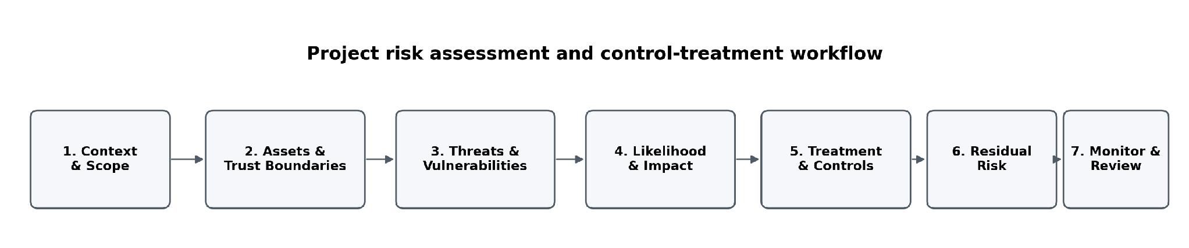
Figure 1. Risk assessment and control-treatment workflow used in this artefact.

2. Risk Assessment Method and Scoring Model

2.1 Methodological Basis
The risk method is intentionally lightweight enough for a student prototype but structured enough to be repeatable. NIST SP 800-30 defines risk assessment around threat sources/events, vulnerabilities, likelihood, impact and risk determination. NIST CSF 2.0 is then used to organise control outcomes across Govern, Identify, Protect, Detect, Respond and Recover. The ASD Information Security Manual and Essential Eight provide Australian security guidance relevant to future implementation. The project does not claim formal compliance with these frameworks; they provide a defensible vocabulary for prioritising controls.

2.2 Likelihood Scale
Score | Likelihood | Project interpretation
1 | Rare | Would require exceptional circumstances or multiple control failures.
2 | Unlikely | Plausible, but not expected during ordinary prototype use.
3 | Possible | Could occur during the project or a small deployment if conditions align.
4 | Likely | Expected to occur repeatedly unless actively controlled.
5 | Almost certain | Already observed in testing, or expected whenever the relevant condition occurs.

2.3 Impact Scale
Score | Impact | Project interpretation
1 | Insignificant | Minimal inconvenience; no meaningful loss of confidentiality, integrity, availability or detection value.
2 | Minor | Limited rework or short-lived monitoring impact; easily recoverable.
3 | Moderate | Material loss of detection quality, analyst time, evidence quality or prototype availability.
4 | Major | Serious operational disruption, high false-alert burden, security-control failure or exposure of sensitive telemetry.
5 | Severe | Potential compromise of security decisions, unsafe lab escape, widespread evidence/model corruption, or a failure that could materially affect a real financial-services environment.

2.4 Risk Rating and Treatment Rule
Risk score = Likelihood x Impact. Scores 1-4 are Low, 5-9 Medium, 10-16 High and 17-25 Extreme. In this prototype, Extreme inherent risks require explicit treatment before the related capability can be presented as suitable for deployment. High residual risks require an owner and further treatment or formal acceptance. Medium risks can be accepted only with monitoring and documented controls. Low risks can normally be accepted within prototype scope.
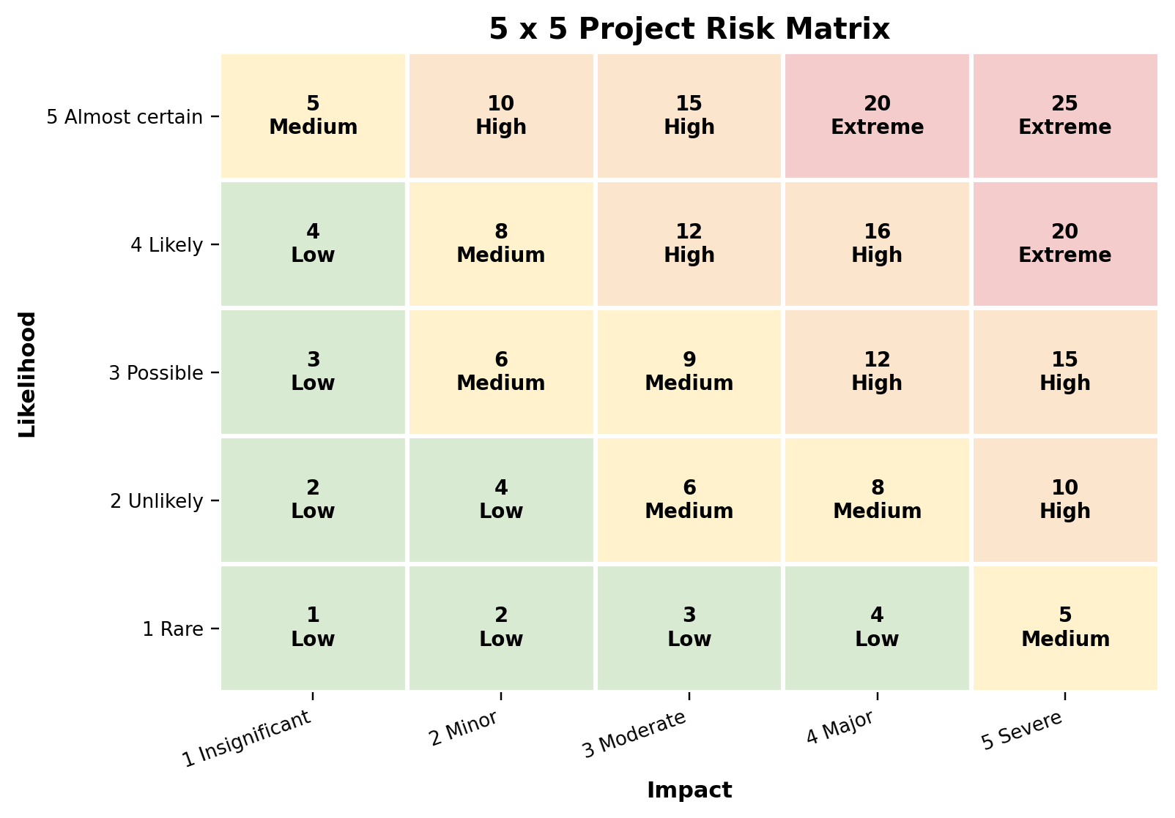
Figure 2. Five-by-five risk matrix used for inherent and residual risk scoring.

2.5 Evidence Used to Score Risk
Risk scoring is not based only on generic cyber-security assumptions. Where available, project evidence is used to adjust likelihood. Examples include the observed failure of transferred source thresholds on both target domains, the calibration-session mismatch in practical traffic, the fixed feature-order dependency, the Hybrid score-saturation behaviour, the isolated lab design, the retained PCAP/Zeek evidence and the fact that the prototype does not automatically block traffic. Where no direct test exists, the score is identified as a design judgement and the proposed verification action is recorded.
Evaluation-evidence boundary: the frozen NF-CSE threshold experiment used 700,000 sampled records, while the target-recalibrated evaluation used a distinct 600,000-record held-out population after reserving normal traffic for calibration. The GNS3/Zeek frozen-threshold evaluation used 6,966 records; the recalibrated evaluation used 5,021 records after reserving 1,945 normal records. These results demonstrate operational risk and the value of evaluating recalibration, but differences in measured rates across those stages must not be attributed solely to threshold changes without controlling the evaluated population.

3. Assets, Trust Boundaries and Security Assumptions

3.1 Asset Inventory
Asset ID | Asset | Security value / why it matters | Primary properties
A-01 | Raw and processed network datasets | Inputs to model development and evaluation; corruption changes model behaviour. | Integrity, provenance, availability
A-02 | Saved preprocessor and feature-order contract | Defines the exact 41-column model input. Silent mismatch can produce plausible but invalid scores. | Integrity, authenticity, version control
A-03 | Six trained/fitted model artefacts | Core detection logic used across all environments. | Integrity, authenticity, availability
A-04 | Threshold configuration and calibration records | Converts scores into alerts and therefore directly controls operational FPR/recall. | Integrity, provenance, change control
A-05 | Zeek logs and PCAP evidence | Supports practical dataset construction, investigation and reproducibility. | Confidentiality, integrity, retention
A-06 | Streamlit dashboard and SQLite alert database | Analyst-facing evidence and persistent alert history. | Confidentiality, integrity, availability
A-07 | Source code, notebooks and configuration | Reproducibility and future maintenance depend on trustworthy code/configuration. | Integrity, version control, availability
A-08 | GNS3/VMware lab network and attack hosts | Provides controlled malicious traffic; unsafe routing could affect unintended systems. | Isolation, availability, authorisation
A-09 | Analyst judgement and operational workflow | Final interpretation remains human-led; misleading outputs can create bad decisions. | Accuracy, explainability, accountability

3.2 Trust Boundaries
Boundary | Trusted side | Less-trusted / external side | Required control
TB-01 | Saved source preprocessing/model artefacts | New target-domain records | Schema validation, version checks, no refitting during frozen evaluation.
TB-02 | Normal-only calibration set | Unknown or malicious target traffic | Calibration separation, curation and held-out evaluation.
TB-03 | Isolated GNS3/VMware lab | Host/Internet/production networks | Private/host-only routing, route verification, no production targets.
TB-04 | Zeek/PCAP evidence store | User access and repository workflows | Least privilege, integrity protection, controlled retention.
TB-05 | Streamlit/SQLite prototype | Analyst browser/session | Authentication and access control required before real deployment.
TB-06 | Approved project source/configuration | Third-party packages and updates | Pinned versions, review and vulnerability management.

3.3 Security Assumptions
- Attack generation remains inside the authorised lab and is not aimed at production systems.
- Normal calibration traffic is intended to represent benign behaviour, but contamination remains possible and is treated as a risk.
- Ground-truth labels are used for evaluation only and are not required for normal-only model fitting.
- The dashboard is a prototype and is not assumed to provide production-grade authentication, high availability or concurrency.
- Network-flow metadata may still be sensitive even though packet payload/customer financial content is not required.
- No single model or threshold is assumed to be universally reliable across networks or capture sessions.

4. Threat and Vulnerability Analysis

4.1 Data and Feature-Pipeline Threats
Threats include accidental schema changes, column reordering, invalid values, stale preprocessing objects, malicious or accidental modification of CSV/NPZ/configuration files, and feature mappings that are structurally valid but semantically different. The danger is high because many ML libraries will accept a numeric array of the correct shape even when its columns are wrong. The resulting predictions can look confident while being meaningless.

4.2 Model and Threshold Threats
The models are normal-only detectors, so the main security risk is not only model compromise but unsafe interpretation. Distribution shift can move normal target scores above a source threshold. Contaminated calibration data can move the threshold in the opposite direction and suppress alerts. A poorly selected operating point can therefore create either alert overload or missed attacks without any change to model weights. The current Hybrid score saturation is an additional implementation-specific vulnerability because tied extreme scores reduce threshold controllability.

4.3 Laboratory and Monitoring Threats
The lab intentionally generates scanning, bursts, failed SSH and transfer-like activity. The main safety threat is loss of isolation through an unintended route, bridge or shared adapter. Monitoring risk also exists: a disabled or misconfigured Zeek sensor, dropped traffic or missing logs can create false confidence because absence of evidence may be mistaken for absence of attacks.

4.4 Dashboard, Storage and Evidence Threats
SQLite and Streamlit are appropriate for a student prototype but introduce production risks: unauthorised access, weak session control, database tampering, local-file loss, lack of concurrency and limited audit protection. The dashboard must therefore be treated as an investigation interface rather than a hardened SOC platform. Alert records, source/destination metadata and Zeek evidence also require controlled access because network metadata can reveal infrastructure and user behaviour.

4.5 Software Supply-Chain and Repository Threats
The implementation depends on Python, scikit-learn, TensorFlow/Keras, Pandas, NumPy, Zeek, Streamlit and other packages. Unpinned or vulnerable dependencies can change behaviour or introduce exploitable defects. Repository workflows can also expose raw logs, large datasets, credentials or unreviewed configuration if files are committed without filtering. Version pinning, code review, .gitignore controls and separation of raw evidence from public artefacts are therefore part of security, not only project organisation.

5. Detailed Project Risk Register
The following register records inherent risk before treatment and the expected residual risk after the listed controls. Residual scores represent a reasoned prototype assessment, not a certified security measurement. Risk owners are roles rather than individual students so the register remains usable after handover.
Interpretation of residual scores: the register combines controls already demonstrated in the academic prototype with proposed treatments. Its residual values are therefore conditional forecasts after the stated treatment package, not measurements of current residual risk. Where authentication, integrity protection, multi-session drift monitoring, backup/restore testing or formal change approval remain future work, those risk reductions must not be represented as achieved. A production owner would need to reassess residual likelihood and impact after implementing and verifying each control.
ID | Risk | Cat. | L | I | Inh. | Rating | Existing / proposed controls | Res. | Owner
R01 | Cross-domain score shift | Model / Detection | 5 | 4 | 20 | Extreme | Frozen transfer baseline; target-normal recalibration; multi-budget sensitivity; drift/session review. | 9 Medium | Model Evaluation Lead
R02 | Contaminated target-normal calibration data | Data / Calibration | 3 | 5 | 15 | High | Curated normal windows; separate calibration/test sets; anomaly review of calibration pool; future dual approval. | 8 Medium | Data/Model Lead
R03 | Feature-schema or column-order mismatch | Data / Interface | 3 | 5 | 15 | High | Saved preprocessor; fixed feature order; schema checks; fail on missing required fields; versioned feature dictionary. | 8 Medium | Data Engineering Lead
R04 | Threshold misconfiguration or threshold drift | Decision layer | 4 | 4 | 16 | High | Threshold metadata/provenance; controlled budgets; change log; rollback to approved operating point. | 8 Medium | Model Evaluation Lead
R05 | False-positive alert overload | Operational | 5 | 4 | 20 | Extreme | FPR as first-class metric; target calibration; severity/filtering; model comparison; analyst review. | 9 Medium | Security Operations Owner
R06 | False negatives / missed attacks | Detection | 4 | 5 | 20 | Extreme | Multiple metrics; complementary models; scenario testing; threshold trade-off review; escalation of uncertainty. | 12 High | Security Operations Owner
R07 | Hybrid score saturation / tied scores | Model | 4 | 3 | 12 | High | Do not select current Hybrid as low-FPR final detector; redesign score normalisation; re-test before use. | 6 Medium | Model Development Lead
R08 | Exposure of sensitive network-log metadata | Confidentiality | 3 | 4 | 12 | High | Metadata minimisation; avoid payload/customer financial data; future RBAC/encryption/retention controls. | 6 Medium | Future System Owner
R09 | Log, PCAP or alert-evidence tampering | Integrity | 3 | 4 | 12 | High | Retain originals; future checksums, protected central logging, append-only storage and access auditing. | 8 Medium | Network/Lab Lead
R10 | Unauthorised Streamlit / SQLite access | Application | 3 | 4 | 12 | High | Local/prototype restriction now; future authentication, least privilege, TLS and protected DB permissions. | 6 Medium | Dashboard Lead
R11 | Lab isolation failure / traffic escape | Network / Safety | 2 | 5 | 10 | High | Isolated 192.168.10.0/24 lab; controlled routes/adapters; route checks; no production targets. | 5 Medium | Network/Lab Lead
R12 | Misuse of offensive test tooling | Operational / Safety | 2 | 4 | 8 | Medium | Authorised lab-only procedures; restricted scope; documented commands; no real targets. | 4 Low | Network/Lab Lead
R13 | Vulnerable or unpatched software dependencies | Supply chain | 3 | 4 | 12 | High | Pinned requirements where available; future dependency scanning, patch review and controlled upgrades. | 8 Medium | Development Lead
R14 | Model/preprocessor artefact tampering or version mismatch | Integrity / ML | 3 | 5 | 15 | High | Versioned artefacts; repository history; future SHA-256 hashes/signatures and load-time verification. | 8 Medium | Model/Data Lead
R15 | Prototype scalability / availability limit | Availability | 4 | 3 | 12 | High | Prototype scope explicitly batch/offline; future queue/stream ingestion and production database. | 6 Medium | Architecture Owner
R16 | Loss of model, config, log or PCAP evidence | Resilience | 3 | 4 | 12 | High | Git repository + saved artefacts; future protected backups, restore tests and retention schedule. | 6 Medium | Project Lead
R17 | Insufficiently representative normal calibration data | Calibration | 4 | 4 | 16 | High | Dedicated normal calibration; held-out normal test; collect multiple sessions/sources; periodic revalidation. | 9 Medium | Model Evaluation Lead
R18 | Traffic drift / ageing benchmark assumptions | Lifecycle | 4 | 4 | 16 | High | Drift monitoring; periodic recalibration/retraining review; newer target data; performance revalidation. | 9 Medium | Future System Owner
R19 | Accidental repository exposure of raw/sensitive artefacts | Repository | 3 | 4 | 12 | High | Commit code/config/previews only; .gitignore; review staged files; keep large raw evidence in controlled storage. | 6 Medium | Repository Maintainer
R20 | Zeek sensor or capture-path failure | Monitoring | 3 | 3 | 9 | Medium | Zeek service/log health checks; expected-volume monitoring; future redundancy/heartbeat alert. | 6 Medium | Network/Lab Lead
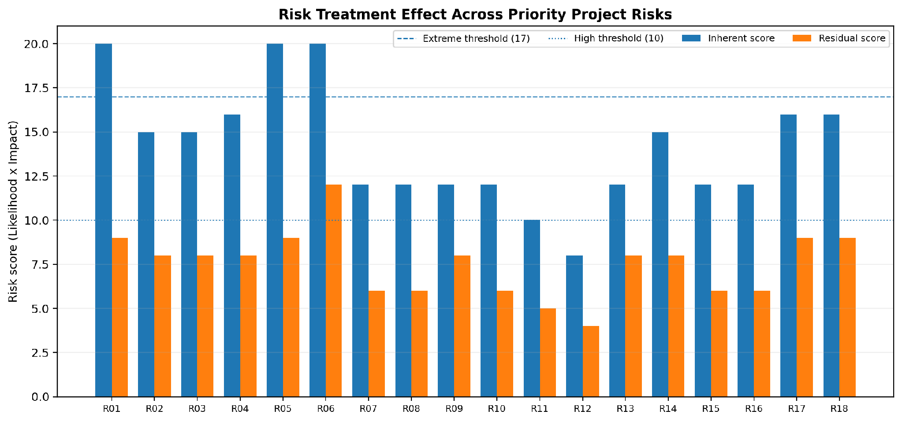
Figure 3. Comparison of inherent and residual risk scores after the proposed treatments.

5.1 Highest-Priority Risks
The most significant inherent risks are not conventional malware threats against the prototype itself. They are risks that can make the detector produce unsafe security decisions: source-to-target score shift, false-positive overload, missed attacks, threshold drift and unrepresentative normal calibration. These risks deserve priority because they directly affect the reliability of every alert presented to an SME analyst. The project testing has already demonstrated that these conditions are realistic, not hypothetical.

5.2 Residual High Risk Requiring Explicit Acceptance
R06 - missed attacks - remains High after treatment because no unsupervised detector can guarantee complete attack coverage, and the project has observed scenario-specific blind spots. This residual risk must not be hidden by selecting a favourable aggregate metric. A real deployment would need defence in depth: anomaly detection would complement, not replace, firewalls, endpoint controls, identity protection, signature detection and incident-response processes.

6. Security Controls and Framework Mapping
Controls are classified as Implemented, Partial or Future. This prevents a design recommendation from being misrepresented as an existing prototype capability. The NIST CSF 2.0 function mapping is used to organise outcomes rather than to claim formal conformance.
Control-evidence rule: “Implemented” means the supplied project documentation describes a working prototype mechanism; it does not imply independent penetration testing or operational assurance. “Partial” means a subset of the proposed control is present, while “Future” and “Recommended next” indicate work not demonstrated. In particular, dashboard severity/context, saved files and repository history do not by themselves establish enforced access control, tamper-evident evidence, reliable alert triage or disaster recovery.
ID | Control | Status | Primary risk(s) | CSF 2.0 function | Project evidence / implementation
SC-01 | Isolated GNS3/VMware attack lab and controlled routes | Implemented | R11, R12 | Protect | 192.168.10.0/24 practical lab; attacks generated against lab endpoints only.
SC-02 | Passive Zeek network monitoring | Implemented | R20 | Detect | Zeek connection/protocol logs and PCAP evidence retained.
SC-03 | Saved preprocessing and fixed feature-order contract | Implemented | R03, R14 | Identify / Protect | Saved transformer, fixed model-ready ordering and feature mapping.
SC-04 | Calibration/test separation | Implemented | R02, R17 | Govern / Identify | Normal-only calibration records kept separate from held-out evaluation.
SC-05 | Frozen-model transfer protocol | Implemented | R01, R04 | Govern / Identify | Target experiments preserve trained model parameters; threshold changes are separated from retraining.
SC-06 | Threshold provenance and controlled operating points | Partial | R04, R05, R06 | Govern | Threshold budget/source recorded in evaluation outputs; formal production approval workflow not implemented.
SC-07 | Explicit FPR and multi-metric monitoring | Implemented | R05, R06 | Detect | Precision, recall, F1, FPR, ROC-AUC and PR-AUC used; FPR treated separately.
SC-08 | Human analyst review; no automatic blocking | Implemented by design | R05, R06 | Respond | Prototype presents evidence and alerts but does not automatically block traffic.
SC-09 | PCAP/log/model/config evidence retention | Implemented / Partial | R09, R16 | Detect / Recover | Project artefacts retained; production integrity and backup controls still required.
SC-10 | Repository/version-control workflow | Partial | R13, R14, R16, R19 | Govern / Protect | Code/configuration retained in project repository; stronger release signing and secret scanning are future work.
SC-11 | Dashboard/SQLite authentication and least privilege | Future | R08, R10 | Protect | Required before deployment; current student prototype should not be treated as internet-facing.
SC-12 | Encryption, integrity hashes and protected backups | Future | R08, R09, R14, R16 | Protect / Recover | Use TLS, encrypted storage, SHA-256/signing, protected backup and restore testing.
SC-13 | Dependency vulnerability and patch management | Future / Partial | R13 | Govern / Protect | Pin versions; add software-composition analysis and controlled update testing.
SC-14 | Severity, filtering and alert prioritisation | Implemented in prototype | R05 | Detect / Respond | Dashboard provides analyst-facing prioritisation/context.
SC-15 | Multi-session normal calibration and drift monitoring | Recommended next | R01, R04, R17, R18 | Identify / Detect | Collect representative normal sessions and monitor realised FPR/score distributions over time.
SC-16 | Recovery and rollback procedure | Future | R04, R14, R16 | Recover | Versioned model/threshold releases, backup/restore and rollback to last approved configuration.
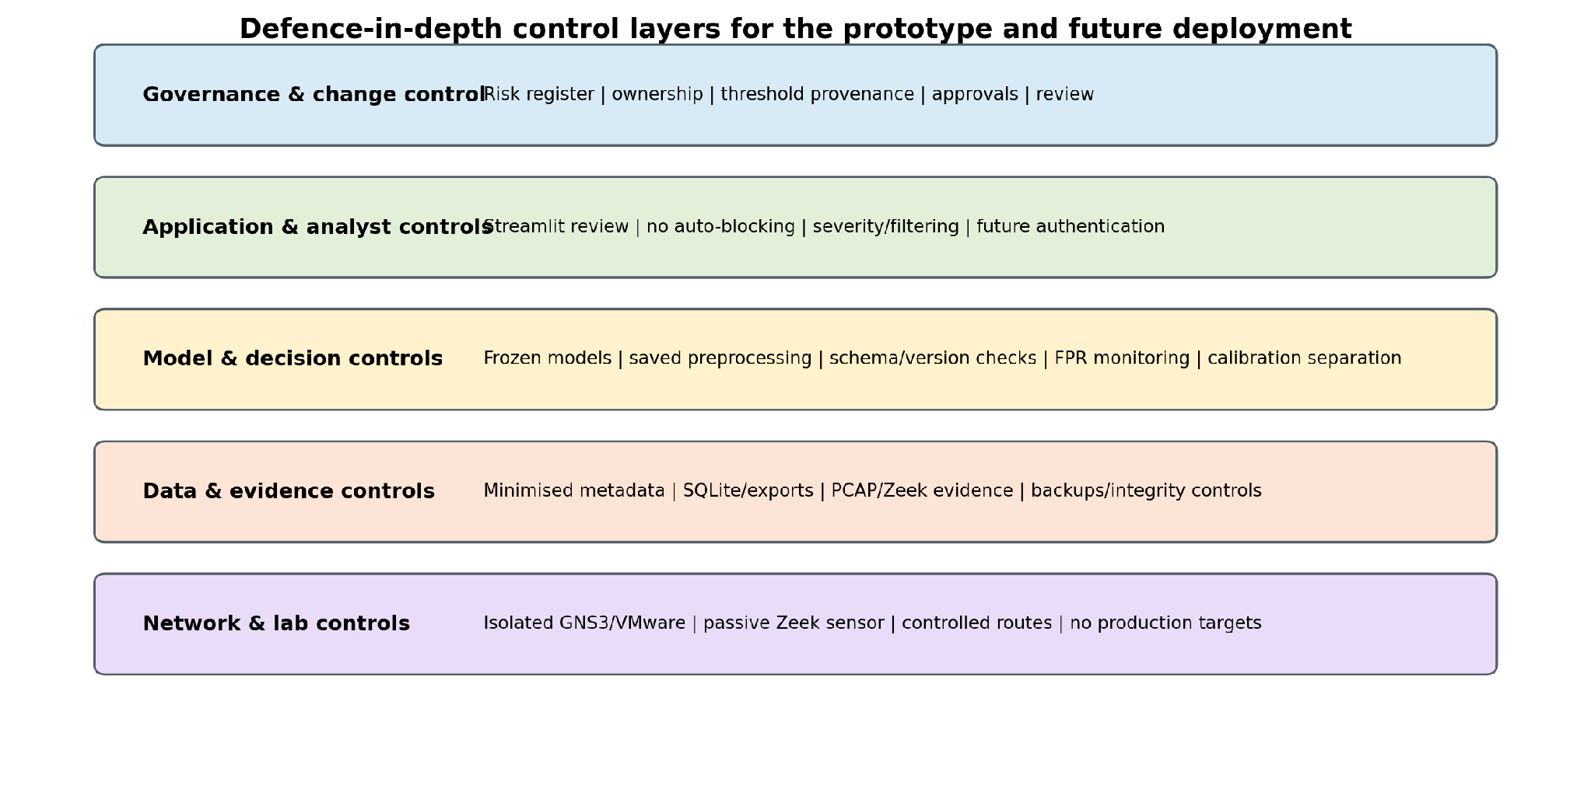
Figure 4. Defence-in-depth control layers spanning the prototype and future production hardening.

6.1 Control Design Principles
- Fail visibly on schema mismatch. A missing or reordered feature should stop or quarantine scoring rather than produce a silent prediction.
- Separate learning from decision policy. Model artefacts and threshold configuration should be versioned independently so an operating-point change is auditable.
- Treat normal calibration data as security-sensitive input. If the baseline is poisoned or unrepresentative, the detector can be weakened without touching model code.
- Preserve human oversight. An anomaly score is evidence for investigation, not proof of malicious intent.
- Protect the evidence path. Logs, PCAPs, thresholds and model versions must remain traceable so an alert can be reconstructed after the event.
- Design for rollback. Thresholds, models and preprocessing changes should be reversible to a previously approved package.

6.2 Australian Security Guidance Alignment
For a future Australian deployment, the ASD Information Security Manual provides a broader risk-based security framework, while the Essential Eight supplies prioritised mitigation strategies for internet-connected enterprise IT. The project prototype does not implement or claim a particular Essential Eight maturity level. Nevertheless, several future controls are consistent with that guidance: controlled patching, restricting privileged access, application control, multi-factor authentication for administrative access, regular backups and protection of security logs. These controls should be implemented around the anomaly detector rather than assuming the detector itself provides them.

7. Risk Treatment Priorities and Residual Risk

7.1 Priority 1 - Required Before Any Real Deployment
Priority action | Risks reduced | Why required
Add authentication, role-based access and secure transport for Streamlit/SQLite. | R08, R10 | The current prototype is not a hardened multi-user service.
Protect model, preprocessor, threshold and log artefacts with hashes/signing and release versioning. | R09, R14, R16 | Security decisions depend on the integrity of these files.
Use multi-session normal calibration with contamination checks and independent held-out normals. | R01, R02, R04, R17, R18 | Project testing shows calibration behaviour can change across sessions/environments.
Introduce dependency scanning, controlled patching and secrets/repository checks. | R13, R19 | Reduces software supply-chain and accidental disclosure risk.
Implement central protected log storage, backups and restore testing. | R08, R09, R16 | Evidence must survive endpoint/database loss or compromise.

7.2 Priority 2 - Required for Operational Maturity
- Automated drift monitoring for score distributions, realised FPR and feature statistics.
- Zeek sensor health/heartbeat monitoring and expected-log-volume checks.
- Streaming ingestion and a production-grade database/message queue for higher traffic volume.
- Repeat low-count attack scenarios and maintain a regression test set for each supported release.
- Documented incident escalation, threshold rollback and model-release approval procedures.

7.3 Priority 3 - Resilience and Scale Enhancements
- Redundant sensing or alternate telemetry source for monitoring continuity.
- Integration with SIEM/SOAR for central alert correlation, while preserving human approval before automated response.
- Formal backup retention, disaster-recovery objectives and periodic restore exercises.
- Independent security review/penetration testing of the hardened dashboard/API before exposure beyond a controlled environment.

8. Control Verification and Assurance Plan
A control is only useful if its operation can be evidenced. The following tests translate the control design into repeatable assurance activities.
Test ID | Control / risk | Verification procedure | Expected evidence | Frequency
SV-01 | SC-01 / R11 | Inspect VM adapters, routes and gateways before attack tests; confirm no production target is reachable from the attack subnet. | Route table/screenshot and approved topology. | Before each attack campaign
SV-02 | SC-03 / R03 | Remove or reorder a required feature in a test copy. | Pipeline rejects/quarantines incompatible input rather than silently scoring. | Each pipeline release
SV-03 | SC-04 / R02 | Hash calibration and held-out record IDs/sources and compare intersections. | No overlap between calibration and held-out evaluation. | Each evaluation run
SV-04 | SC-06 / R04 | Load threshold configuration and verify model ID, dataset/session, percentile and timestamp. | Run metadata uniquely identifies the operating point. | Each model release
SV-05 | SC-07 / R05/R06 | Compare FPR, recall and false alerts per 1,000 normals across release candidates. | No release accepted from F1/recall alone. | Each model/threshold change
SV-06 | SC-09 / R09 | Calculate checksums for representative PCAP/log/model/config files and re-check after transfer/storage. | Checksums match; alterations are detected. | Future: each release/collection
SV-07 | SC-11 / R10 | Attempt unauthenticated/unauthorised access to dashboard and database in hardened build. | Access denied and attempt logged. | Before deployment and after auth changes
SV-08 | SC-12 / R16 | Restore model/config/database/log backup into a clean environment. | Service and evidence can be restored from approved backup. | Future: scheduled recovery test
SV-09 | SC-13 / R13 | Run dependency audit/software-composition scan and review critical findings. | No unaccepted critical/high dependency vulnerabilities. | Each release / monthly
SV-10 | SC-15 / R17/R18 | Compare calibration and held-out normal score distributions across capture sessions. | Material drift triggers review/recalibration rather than silent continuation. | Each new session / scheduled review
SV-11 | SC-02 / R20 | Stop/disable Zeek in a controlled test and monitor health indicator. | Monitoring failure becomes visible; no silent “all clear”. | Before production rollout

8.1 Change-Control Gate for Model and Threshold Releases
Gate | Required evidence
G1 - Data contract | Feature dictionary/version, preprocessor ID, shape/order checks passed.
G2 - Model integrity | Model artefact version/hash and training provenance recorded.
G3 - Calibration | Calibration source is approved normal traffic and separated from held-out data.
G4 - Evaluation | Precision, recall, F1, FPR, ROC-AUC/PR-AUC where available, plus scenario limitations reviewed.
G5 - Operational impact | Expected false-alert load and analyst workflow reviewed.
G6 - Security | Dependency, repository and access-control checks complete for deployment package.
G7 - Rollback | Previous approved model/threshold/configuration remains recoverable.

9. Operational Response and Recovery Considerations

9.1 Alert Triage
The prototype is designed to support investigation, not autonomous enforcement. A high anomaly score should trigger contextual review: model identity, threshold version, source/destination/protocol metadata, related Zeek evidence, severity/context and explanation outputs where supported. An analyst should distinguish model uncertainty from confirmed malicious behaviour before escalation.

9.2 Response to Excessive False Positives
Step | Action
1 | Confirm sensor/data pipeline health and feature-order/version integrity.
2 | Check whether the threshold/configuration changed and verify provenance.
3 | Compare current normal score distribution with the approved calibration baseline.
4 | If drift is confirmed, collect a clean representative normal calibration window.
5 | Recalibrate the threshold with models frozen, evaluate on independent held-out normal/attack data and obtain approval.
6 | Roll back if the new operating point increases risk or cannot be validated.

9.3 Response to Suspected Model or Evidence Tampering
If model, preprocessor, threshold, database or log integrity is in doubt, the affected outputs should not be trusted. The response should preserve the suspect artefact, compare hashes/versions against the approved release, restore known-good artefacts, re-run a controlled verification dataset and document the incident. In a production design, model/configuration files should be treated with the same change-control discipline as other security-critical software.

9.4 Recovery Priorities
- Restore trusted preprocessing/model/threshold package before resuming scoring.
- Restore alert database and evidence logs from protected backup, preserving chain-of-custody metadata where relevant.
- Validate Zeek captures health and time consistency before interpreting new alerts.
- Re-run a regression sample to verify scores and decisions match the approved baseline.
- Review why the control failed and update the risk register, verification plan and architecture if necessary.

10. Limitations and Risk Acceptance
- The likelihood and impact scores are project-level judgements, not statistically calibrated probabilities. They are intended to prioritise treatment and make assumptions explicit.
- The practical environment is an isolated student laboratory, not a production financial-services network; real infrastructure, identity systems, cloud services and business processes would add further risks.
- Several recommended controls - authentication, encryption, centralised immutable logging, artefact signing, dependency scanning and backup restore testing - are not fully implemented in the prototype and are labelled Future rather than claimed as complete.
- The assessment does not replace a formal organisational risk process or legal/compliance assessment. TA8 separately evaluates ethical, legal and professional considerations.
- ML detection risk cannot be reduced to zero. False negatives remain a High residual risk and must be accepted only within a defence-in-depth architecture.

10.1 Risk Acceptance Statement for Prototype Scope
Within the controlled academic prototype, Medium residual risks are acceptable where the relevant control and limitation are documented and no production claims are made. High residual risk R06 (missed attacks) is tolerated only because the system is demonstrative, passive and used alongside known ground truth for evaluation. It would require explicit business/security-owner acceptance and complementary controls in any real deployment. No Extreme residual score is projected after the proposed treatment package; this is not a verified statement of current deployment risk.

11. Recommendations and Implementation Priorities
Priority | Recommendation | Outcome
1 | Harden dashboard/database access with MFA-capable authentication, RBAC, TLS and least privilege. | Protects analyst interface and alert data.
1 | Introduce signed/hashed release packages for model, preprocessor, feature order and threshold configuration. | Prevents silent artefact substitution and enables rollback.
1 | Use multi-session target-normal calibration and contamination screening. | Reduces threshold/session mismatch risk.
1 | Centralise and protect Zeek/PCAP/alert logs with integrity and backup controls. | Improves investigation reliability and recovery.
2 | Automate drift, FPR and sensor-health monitoring. | Makes degradation visible before alert quality becomes unusable.
2 | Implement dependency scanning and controlled update process. | Reduces software supply-chain risk.
2 | Redesign Hybrid score normalisation and repeat threshold testing. | Addresses score saturation and improves controllability.
2 | Repeat low-count attack scenarios across independent sessions. | Strengthens confidence in scenario-specific detection.
3 | Move from SQLite/batch operation to scalable streaming and production storage if volume requires it. | Improves availability, concurrency and telemetry throughput.
3 | Commission independent security review before external exposure. | Validates application, network and configuration hardening.

12. Conclusion
The project risk assessment shows that the most important security risks are tightly connected to the anomaly-detection architecture itself. A detector can become operationally unsafe without being “hacked”: normal-score distributions can shift, calibration data can be unrepresentative, feature contracts can be misapplied, thresholds can drift, and an attack-heavy evaluation can hide alert overload. The architecture therefore treats schema control, threshold provenance, FPR monitoring, calibration separation and human review as security controls.
The prototype already has meaningful safeguards - isolated attack generation, passive Zeek monitoring, a fixed preprocessing/model contract, separated calibration and held-out evaluation, retained evidence and no automatic blocking. These controls make the current work appropriate for controlled research and demonstration. They are not sufficient for a live financial-services deployment. Authentication, protected logging, artefact integrity, backup/recovery, dependency management, drift monitoring and formal change control are required before exposure to real organisational traffic.
Residual risk remains, especially the possibility of missed attacks. For that reason the anomaly detector should be deployed, if at all, as one layer in a wider defence-in-depth strategy and not as a substitute for established preventive, detective and response controls.

13. References
Australian Signals Directorate (2023) Essential Eight maturity model, Australian Cyber Security Centre, updated November 2023.
Australian Signals Directorate (2026) Information security manual, September 2026, Australian Cyber Security Centre.
National Institute of Standards and Technology (2012) Guide for Conducting Risk Assessments, NIST Special Publication 800-30 Revision 1, Gaithersburg, MD.
National Institute of Standards and Technology (2024) The NIST Cybersecurity Framework (CSF) 2.0, NIST CSWP 29, Gaithersburg, MD.
PG3 Project Team (2026) System Requirements & Architecture Design Report, COIT20265, CQUniversity.
PG3 Project Team (2026) Cross-Domain Evaluation, Threshold Calibration & Sensitivity Analysis Report, COIT20265, CQUniversity.
PG3 Project Team (2026) GNS3/Zeek Practical Network Implementation artefact, COIT20265, CQUniversity.

Appendix A - Risk Treatment Decision Rules
Residual rating | Default treatment decision
Low (1-4) | Accept within documented prototype scope; monitor if the environment changes.
Medium (5-9) | Accept only with named owner/control evidence and scheduled review.
High (10-16) | Further treatment or explicit security/business-owner acceptance required; deployment claim must be qualified.
Extreme (17-25) | Do not accept for deployment; treatment required before proceeding.

Appendix B - Risk Register Narrative Notes
R01 - Cross-domain score shift
Normal target scores can shift above source thresholds, producing mass benign over-flagging.
Treatment: Frozen transfer baseline; target-normal recalibration; multi-budget sensitivity; drift/session review.
Inherent score: 20 (Extreme). Residual score: 9 (Medium). Risk owner: Model Evaluation Lead.
R02 - Contaminated target-normal calibration data
Attack or abnormal records inside a set assumed to be normal can raise thresholds and suppress detection.
Treatment: Curated normal windows; separate calibration/test sets; anomaly review of calibration pool; future dual approval.
Inherent score: 15 (High). Residual score: 8 (Medium). Risk owner: Data/Model Lead.
R03 - Feature-schema or column-order mismatch
Wrong columns, order or semantics can silently invalidate model scores.
Treatment: Saved preprocessor; fixed feature order; schema checks; fail on missing required fields; versioned feature dictionary.
Inherent score: 15 (High). Residual score: 8 (Medium). Risk owner: Data Engineering Lead.
R04 - Threshold misconfiguration or threshold drift
Wrong, stale or undocumented thresholds can change alert behaviour without changing the model.
Treatment: Threshold metadata/provenance; controlled budgets; change log; rollback to approved operating point.
Inherent score: 16 (High). Residual score: 8 (Medium). Risk owner: Model Evaluation Lead.
R05 - False-positive alert overload
High FPR can overwhelm an SME analyst and hide genuine events.
Treatment: FPR as first-class metric; target calibration; severity/filtering; model comparison; analyst review.
Inherent score: 20 (Extreme). Residual score: 9 (Medium). Risk owner: Security Operations Owner.
R06 - False negatives / missed attacks
Strict thresholds or weak score separation can miss malicious traffic.
Treatment: Multiple metrics; complementary models; scenario testing; threshold trade-off review; escalation of uncertainty.
Inherent score: 20 (Extreme). Residual score: 12 (High). Risk owner: Security Operations Owner.
R07 - Hybrid score saturation / tied scores
Tied/saturated Hybrid scores make threshold budgets ineffective.
Treatment: Do not select current Hybrid as low-FPR final detector; redesign score normalisation; re-test before use.
Inherent score: 12 (High). Residual score: 6 (Medium). Risk owner: Model Development Lead.
R08 - Exposure of sensitive network-log metadata
Logs may expose IPs, hostnames, services and behaviour if accessed inappropriately.
Treatment: Metadata minimisation; avoid payload/customer financial data; future RBAC/encryption/retention controls.
Inherent score: 12 (High). Residual score: 6 (Medium). Risk owner: Future System Owner.
R09 - Log, PCAP or alert-evidence tampering
Modified logs or PCAPs can undermine investigation and reproducibility.
Treatment: Retain originals; future checksums, protected central logging, append-only storage and access auditing.
Inherent score: 12 (High). Residual score: 8 (Medium). Risk owner: Network/Lab Lead.
R10 - Unauthorised Streamlit / SQLite access
Prototype interface/database could be accessed or changed by an unauthorised user.
Treatment: Local/prototype restriction now; future authentication, least privilege, TLS and protected DB permissions.
Inherent score: 12 (High). Residual score: 6 (Medium). Risk owner: Dashboard Lead.
R11 - Lab isolation failure / traffic escape
Misconfigured virtual networking could send attack traffic outside the intended lab.
Treatment: Isolated 192.168.10.0/24 lab; controlled routes/adapters; route checks; no production targets.
Inherent score: 10 (High). Residual score: 5 (Medium). Risk owner: Network/Lab Lead.
R12 - Misuse of offensive test tooling
Nmap/Kali and attack scripts can be misused outside the authorised exercise.
Treatment: Authorised lab-only procedures; restricted scope; documented commands; no real targets.
Inherent score: 8 (Medium). Residual score: 4 (Low). Risk owner: Network/Lab Lead.
R13 - Vulnerable or unpatched software dependencies
Third-party package vulnerability or incompatible update can change security/behaviour.
Treatment: Pinned requirements where available; future dependency scanning, patch review and controlled upgrades.
Inherent score: 12 (High). Residual score: 8 (Medium). Risk owner: Development Lead.
R14 - Model/preprocessor artefact tampering or version mismatch
Changed or swapped model/preprocessor files can produce invalid or malicious decisions.
Treatment: Versioned artefacts; repository history; future SHA-256 hashes/signatures and load-time verification.
Inherent score: 15 (High). Residual score: 8 (Medium). Risk owner: Model/Data Lead.
R15 - Prototype scalability / availability limit
SQLite/batch Streamlit design may degrade or fail at higher telemetry volume.
Treatment: Prototype scope explicitly batch/offline; future queue/stream ingestion and production database.
Inherent score: 12 (High). Residual score: 6 (Medium). Risk owner: Architecture Owner.
R16 - Loss of model, config, log or PCAP evidence
Loss of code, config, models, logs or PCAPs prevents reproduction/recovery.
Treatment: Git repository + saved artefacts; future protected backups, restore tests and retention schedule.
Inherent score: 12 (High). Residual score: 6 (Medium). Risk owner: Project Lead.
R17 - Insufficiently representative normal calibration data
A normal calibration session may not represent future normal behaviour.
Treatment: Dedicated normal calibration; held-out normal test; collect multiple sessions/sources; periodic revalidation.
Inherent score: 16 (High). Residual score: 9 (Medium). Risk owner: Model Evaluation Lead.
R18 - Traffic drift / ageing benchmark assumptions
Traffic patterns change over time and old benchmark assumptions become stale.
Treatment: Drift monitoring; periodic recalibration/retraining review; newer target data; performance revalidation.
Inherent score: 16 (High). Residual score: 9 (Medium). Risk owner: Future System Owner.
R19 - Accidental repository exposure of raw/sensitive artefacts
Raw logs/datasets or secrets may be committed to a shared/public repository.
Treatment: Commit code/config/previews only; .gitignore; review staged files; keep large raw evidence in controlled storage.
Inherent score: 12 (High). Residual score: 6 (Medium). Risk owner: Repository Maintainer.
Sensor/capture failure can create blind spots while the system appears healthy.
Treatment: Zeek service/log health checks; expected-volume monitoring; future redundancy/heartbeat alert.
Inherent score: 9 (Medium). Residual score: 6 (Medium). Risk owner: Network/Lab Lead.

